**Requirement Investigation Research**

Brief acquired from Mike Sanderson:

*“The aim of this project is to implement a tool to assist with the teaching of graph algorithms such as those taught in CE204.*

*It should provide a graphical display of step-by-step implementation of the algorithms with accompanying descriptive text. This should be offered at various levels of abstraction (e.g. for Kruskal's algorithm a version showing the connection sets and a more abstract version that uses the concept of not forming a cycle). It should be able to work on arbitrary graphs (i.e. the descriptions should not be based on a particular graph).*

*Ideally there should also be a graphical user interface that allows the user to create graphs by adding nodes at points on the display and creating edges to connect them, allowing the user's chosen graph to be used to demonstrate the algorithm.*

*The tool could be written as a web application or a stand-alone Java program.”*

To get a more thorough understanding of the requirements, I conversed with Mike Sanderson sending multiple emails and having conversations with him on campus.

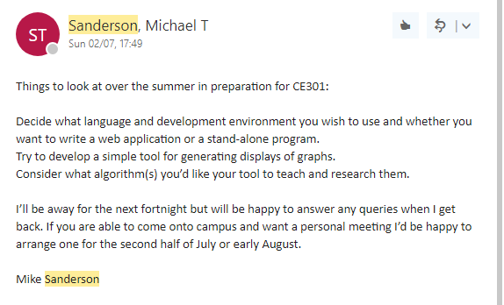

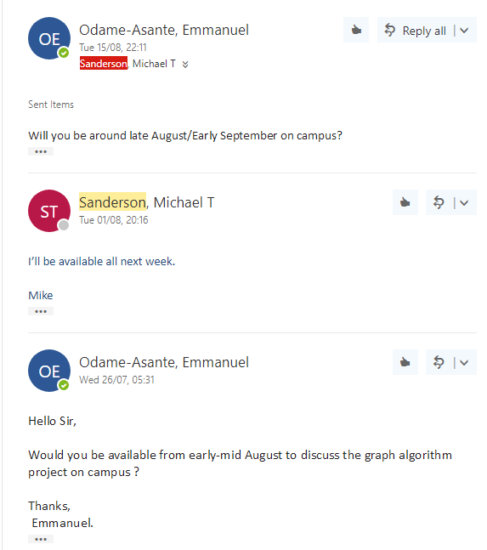

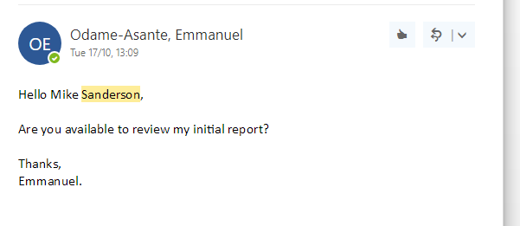

After I got a detailed understand of what Mike Sanderson wanted, I took to the web to look for other tools similarly to mine to shape my ‘personal requirements’. I also looked at mobile apps to as I inspire to get a good application on phone (show this).

The main website I got inspiration from is visualalgo.net.

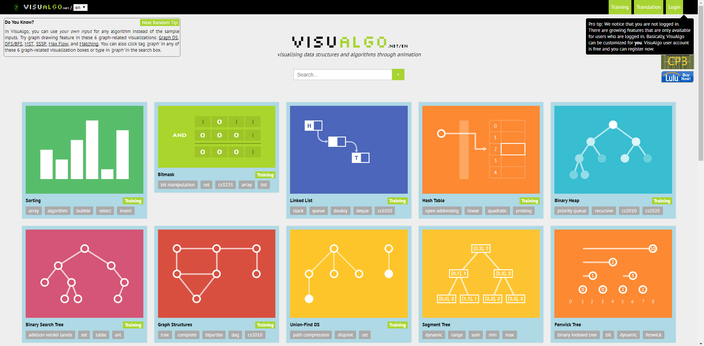

Also University of Berkeley’s tool

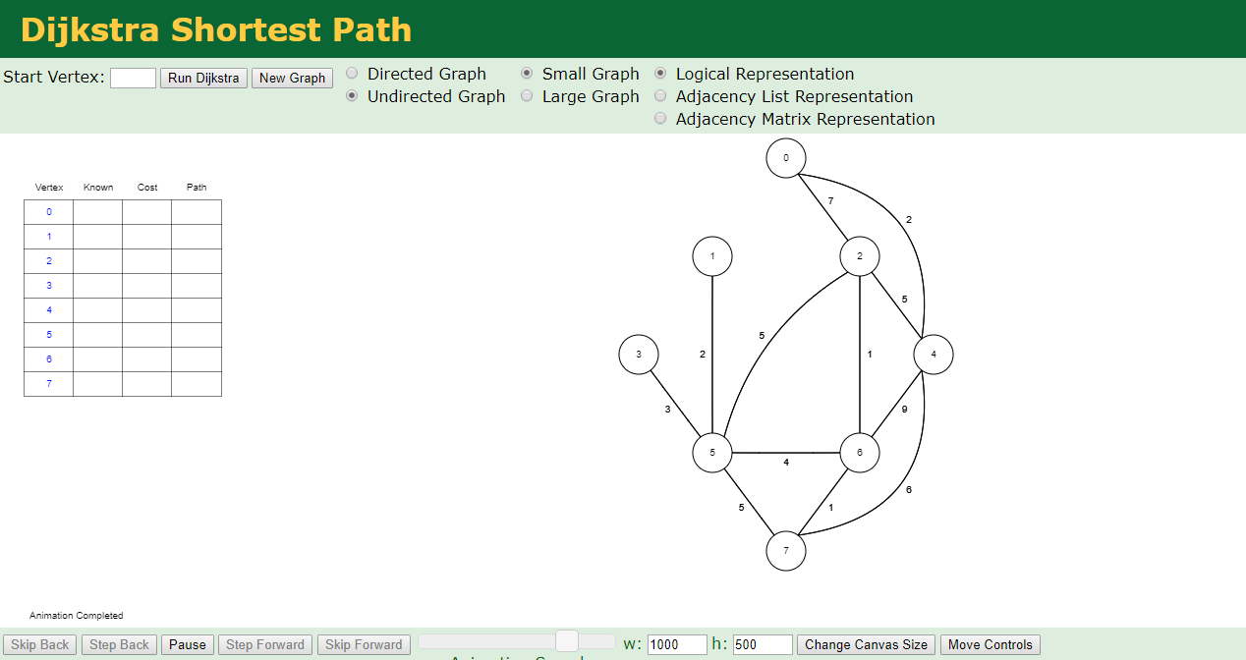

From this I then wrote my own personal requirements of what I want in my application. I split this into different areas such as:

* Web Application
* Dijkstra’s implementation
* Prim’s Implementation
* Kruskal’s Implementation
* Teaching Tool
* User Interaction and customization
* Functional website.
* Mobile optimization
* High test coverage
* Clean JavaScript

This is all into detail in my initial report.

Other useful websites that helped me:

Web Application or Desktop Application?

<https://stackoverflow.com/questions/1072904/advantages-of-web-applications-over-desktop-applications>

<https://www.seguetech.com/desktop-vs-web-applications/>

<http://www.seleniumhq.org/projects/webdriver/>

Mobile Friendliness

<https://developers.google.com/search/mobile-sites/>

Testing

<https://stackoverflow.com/questions/6956190/what-are-the-advantages-of-testing-your-javascript-with-jasmine-a-bdd-approach>

<https://www.quora.com/What-are-the-advantages-and-disadvantages-to-having-some-tests-than-no-tests-at-all-in-JavaScript>

Clean JavaScript

<https://github.com/ryanmcdermott/clean-code-javascript>

<https://blog.risingstack.com/javascript-clean-coding-best-practices-node-js-at-scale/>